C++ Programming for Financial Engineering Level 9 Group F Writeup

QuantNet

Minghan Li

10/28/2019

a)

The sample programs compile and run successfully. The program is trying to simulate a path according to the BS PDE for an underlying security using explicit Euler method.

b)

For Batch 1 - 4, we approximated the price of the put options with different N values (1000, 10000, 100000) and different K values (1, 3, 5). Please see the output folders for the Excel outputs and graphs for each Batch.

In general, a large N value relative to J^2 value will produce good approximation results. For example, for Batch3, when J = 30, all the N values we tested produced good approximations. This is even true when J = 50, where N = 1000 may not produce a good approximation in theory. This means that our rule of thumb N = J\*J condition is a sufficient one but not a necessary one. For a given J, it seems like larger N will only increase the accuracy of the approximation.

On the other hand, for Batch2, when J = 300, N = 1000 produces a bad approximation. It shows that when J is large, the corresponding N must increase to certain extent to accommodate the large J. Similarly, for Batch1, when J = 325, N = 1000 produces a bad approximation as well.

Batch4 is somewhat an anomaly. Almost none of the N could satisfy the condition to produce a solid result. The results are in general displayed as 65535. Although I failed to produce any satisfactory approximation myself, comments from QuantNet confirmed my supposition that much larger N will eventually produce a good result. My conjecture is that the result of FDM is related to the parameter T, since Batch4 clearly has a much larger T than other Batchs.

Another phenomenon worth noting is that the approximation result tends to become bad as the underlying price approaches the strike price. As an example, for Batch1 (J = 195, N = 10000), the graph shows a clear pattern of diverging from exact solution as price approaches 65. Similar findings can be found for various N and J values for Batch 1-3 as well.

Batch 2, J = 300, N = 1000

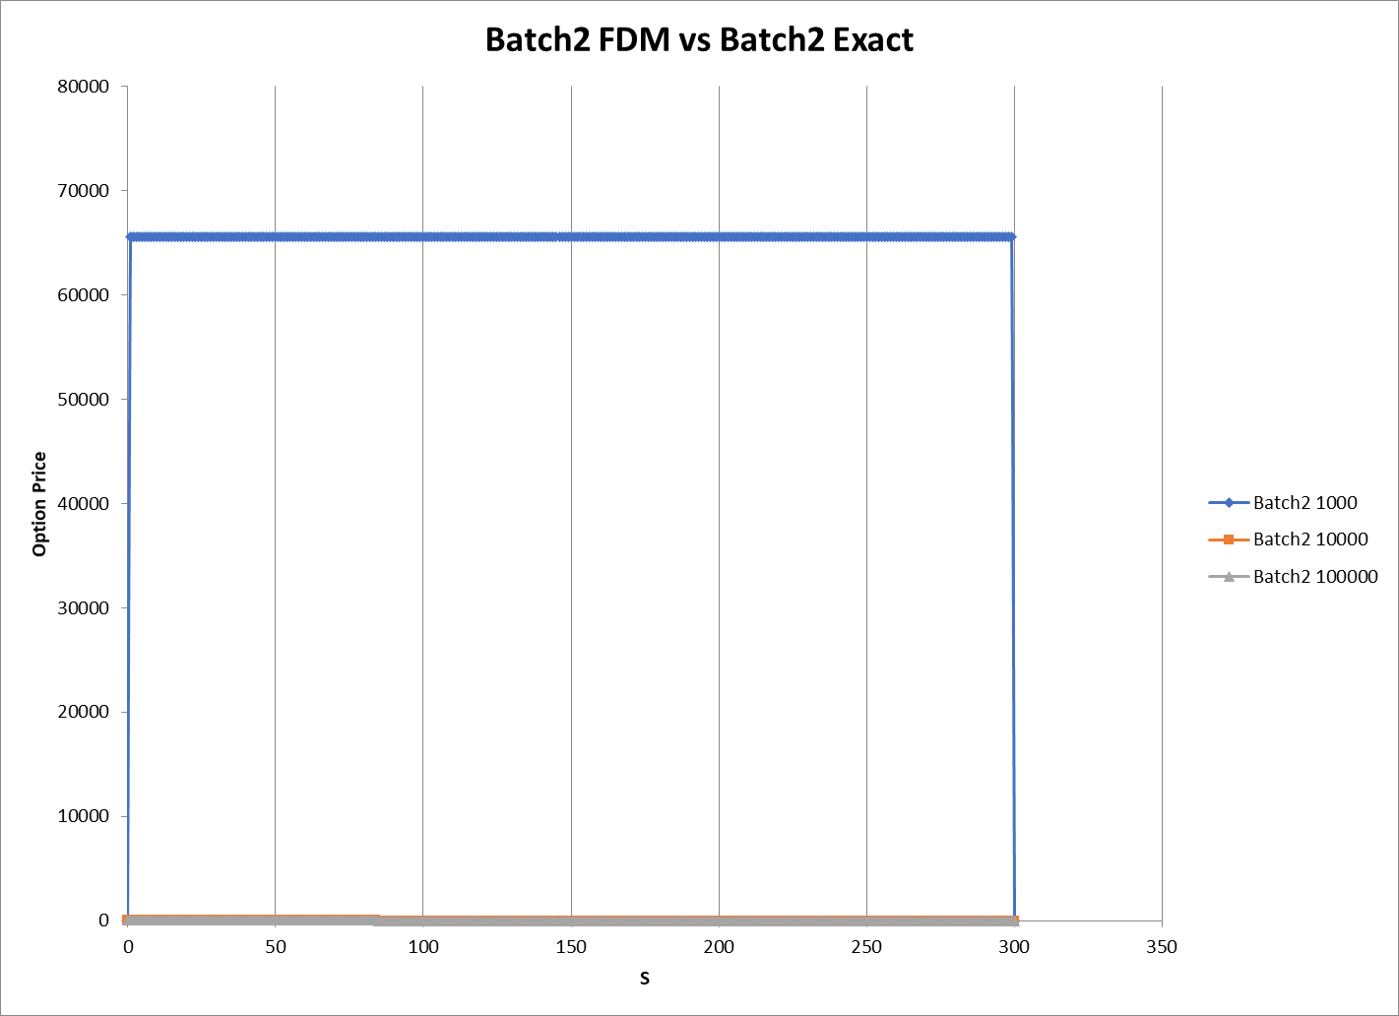

Batch 1, J = 325, N = 1000

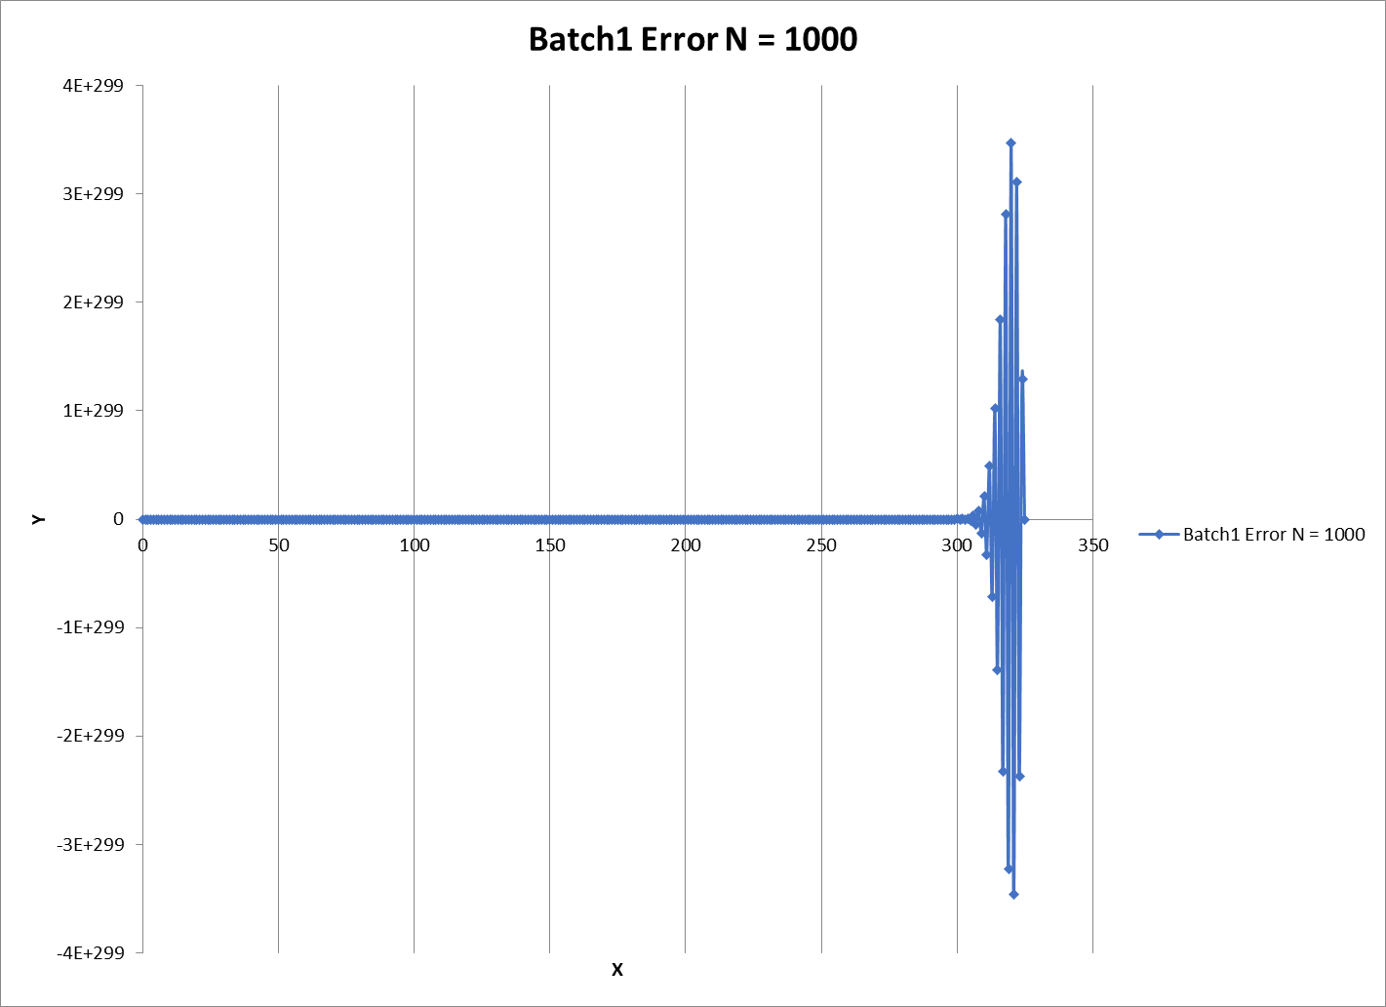

Batch 1, J = 195, N = 10000